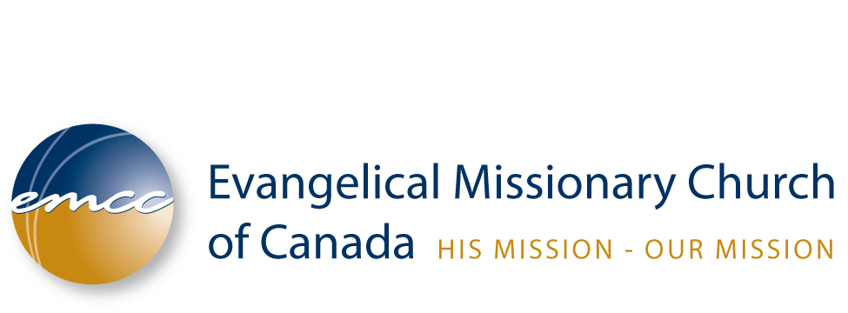

MINISTRY GRANT FUND APPLICATION
Definition:
The Ministry Grant Fund advances the EMCC purpose by providing financial grants, investing in churches, people and program development. A ministry project as defined for the purposes of the MGF is any ministry initiative: a) that advances the Purpose of the EMCC, b) that upholds the Core Values of the EMCC, c) that would be significantly assisted by a specific grant. Ministry Grants are available only to those serving within the EMCC context and who meet the qualifications outlined in this Policy.
Grant Criteria:

General Criteria

a) The maximum grant in all categories shall be $5,000.00 in any calendar year.

b) To be considered, applications are to be made using the MGF Application Form and must be fully completed including all supporting documentation.

c) The applications must be submitted to the attention of the MGF Adjudication Committee at the EMCC Office by the following dates: March 1, June 1, September 1, or December 1 each year.

d) All decisions of the Adjudication Committee are final.

e) An applicant receiving a grant is eligible to reapply 12 months from the quarterly deadline date of his/her original application.

f) An applicant that has been declined may reapply after a period of at least 6 months from the quarterly deadline date of his/her original application.

g) Notification will be sent to all applicants within 60 days of the application quarterly deadline.

h) A list of the awards will be available, upon request, through the EMCC Office, 61 days after the close of submissions.

Grants for Congregational Development:

a) Grants will only be awarded to EMCC congregations in good standing with the EMCC.

b) Grants are for projects that support church growth, church planting, evangelism and outreach.

Grants for Vocational Development:

a) Grants will only be awarded to ministers holding EMCC credentials and serving in an EMCC ministry or congregation. The spouse of a minister who is actively and clearly engaged in the ministry of the spouse's EMCC ministry or congregation, and whose ministry substantially contributes to the work of that EMCC ministry or congregation, and gives evidence of such at application, may also be considered.

b) Grants are for further education to upgrade skills and advance ministry. The grant is not tied to a degree, but rather to the value of the education in upgrading skills or advancing ministry beyond the point presently attained.

Grants for EMCC Ministry Development:

Grants are awarded to EMCC Ministries for the development of new initiatives.
Review of Grants:

Successful applicants must complete a written progress report and submit it to the Adjudication Committee within six months of the award and a final report at the end of the project. This report should document that the grant has been used expressly and only for the project described in the grant application.

Where the Adjudication Committee has determined that the grant has been used for purposes other than the expressed purposes outlined in the grant application, further payments of the grant may be withheld, future applications may be denied or repayment of the grant may be required.

MINISTRY GRANT FUND APPLICATION FORM
A service of the Evangelical Missionary Church of Canada
Revised March 2011

I. INFORMATION ABOUT THE PROJECT

- This application is being made under the following category:

  - Grant for Congregational Development
  - Grant for Vocational Development
  - Grant for Denominational Ministry Development
4. Are you a credentialed minister with EMCC?

B. Name of person making application: On behalf of organization/ministry:

Mailing address with Postal Code:

Phone No.: Fax No.:
E-mail:

Brief description of how the grant will be used:

Explain how this project advances the Purposes and upholds the Core Values of EMCC:

Amount of funding requested: $
Date Funds will be needed by:

Grant cheque should be: Pay to the Order of:

REQUIRED REFERENCES

1 An official recommendation from the board of your local church is required for both Congregational and Vocational grants. The recommendation of the church board must come by formal resolution of the board that is to be quoted in the letter. Please provide a letter by the Secretary to substantiate such resolution.

2 If this is a vocational grant, two Alternate References including at least one past or present employer. (Specify relationship) Please provide the information below for two alternate references.

- Name:
Complete Address:
Home Phone: Business Phone:

- Name:
Complete Address:
Home Phone: Business Phone:

III. INFORMATION ABOUT THE GRANT (use additional paper if needed)

A. Please provide a detailed breakdown or budget showing how the funds will be used.

What other funding sources will you rely on?

- If this is a Vocational Grant, please explain how this project advances your personal education by providing information on past education and goals for future education or training.
- If this is a Congregational Grant, please explain how this project advances the goals and objectives of your church. (What are the goals of this project? When will it be completed? )

RELEASE OF INFORMATION AND DECLARATION OF INTENT

I hereby give EMCC permission to contact persons named as references to ascertain my suitability for a ministry grant. I release all such references from liability for any damage that may result from furnishing such evaluations to you.

I understand that Where the Adjudication Committee has determined that the grant has been used for purposes other than the expressed purposes outlined in the grant application, further payments of the grant may be withheld, future applications may be denied or repayment of the grant may be required.

I hereby declare that the information provided in this application for a ministry grant is complete and accurate.

Signature of Applicant:___________________________ Date:

Please submit this electronic application to:
The MGF Adjudication Committee
mgf@emcc.ca

***Print, Sign & Scan or Fax
RELEASE OF INFORMATION AND DECLARATION OF INTENT

Fax: (519) 894 - 0941

or mail to the whole application to:

Evangelical Missionary Church of Canada
214 Highland Rd, E
Kitchener, ON N2M 3W2

Revised: March, 2011

