Instructions for the 2017 EMCC Relief & Development Offering

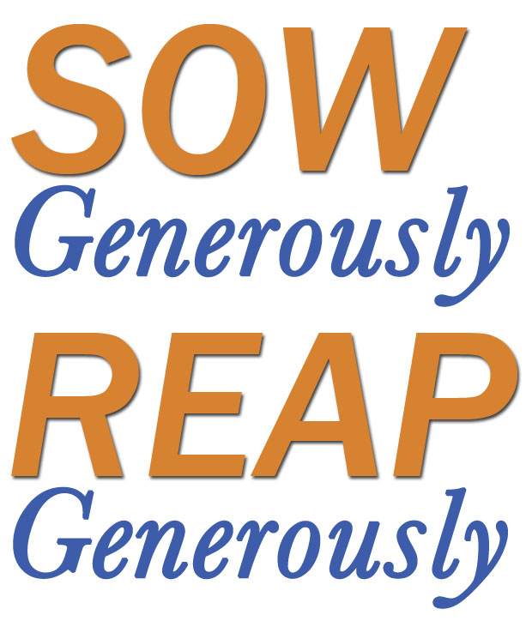

Before your chosen Relief & Development Sunday
- Please pray – for your church and other EMC congregations participating in our Relief & Development campaign and for the people we seek to bless.
- View the R&D PowerPoint. Decide how you might best use this in your service.
- Advance announcement to congregation - Please announce verbally in the two weeks prior to your Relief & Development Sunday.
- Distribute the brochures the week prior to your Relief & Development Sunday (mailed to your church and also available on the EMCC website as part of the R&D package of materials).
- Determine donation options - It is up to local church leadership/treasurer to decide if donations by cheque may be made payable to the local church, or if they prefer donations to be made payable to EMCC or, in the case of CFGB projects - to Canadian Foodgrains Bank. Churches that choose to have donations made payable to the local church need to submit the Treasurers’ Remittance form, detailing the total amounts for each project along with one church cheque to cover all monies submitted for Relief & Development.

Advance Announcement:
“Our Relief and Development campaign is an opportunity for congregations to support the Relief & Development ministry of the EMCC family. Lets Sow Generously so that others may Reap Generously through our care for the impoverished of our world. We encourage you to pray and come prepared to give as the Lord directs you.

On Your Relief & Development Sunday
- Show the R&D PowerPoint.
- Prepare a scripture reading and message related to “Sow Generously – Reap Generously.”
- Project the Relief & Development ppt slide, or otherwise make available the list of projects with project #s.
- Outline donation and sending options and invite the congregation to give during a special offering.
To Donate:
  - Choose a project/s and donation option: (include option a. if approved by leadership/treasurer)
    - Use the church’s envelope and designate funds to EMCC R&D. Make cheques payable to the local church and include the project number on cheque memo line.
    - Use the church’s envelope and designate funds to EMCC R&D. Make cheque out to EMCC and include the project number on the cheque memo line.
Place envelope in church offering plate, or mail cheque to the EMCC office directly.
    - Send cheques for any CFGB Projects directly to Canadian Foodgrains Bank toward the EMCC account. To use this option, cheques must be made payable to Canadian Foodgrains Bank. Indicate ‘EMCC Account’ on cheque memo line.
    - Donate online at www.emcc.ca. (Note that on-line bill payment directly from your bank account is now an option. Contact Lotoya Mahorn (lmahorn@emcc.ca) for details.

After Your Relief & Development Sunday
- If donations for EMCC R&D were made payable to the local church, Treasurers are asked to complete the EMCC R&D 2017 Remittance Form and send it, along with one church cheque to cover total donations directly to EMCC.
- If donations for EMCC R&D were made payable to EMCC, please send the cheques directly to EMCC. Remittance form is not required.
EMCC
214 Highland Rd. E
Kitchener, ON N2M 3W2
- Donations made payable to Canadian Foodgrains Bank should be sent directly to Canadian Foodgrains Bank, 400-393 Portage Ave #400, Winnipeg, MB R3B 3H6. Remittance form is not required.

Thank you for joining with us. “Sow Generously – Reap Generously” by caring for the impoverished.

