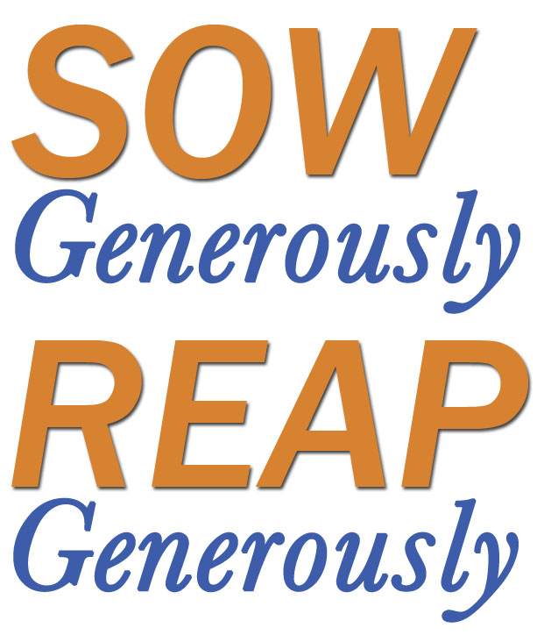
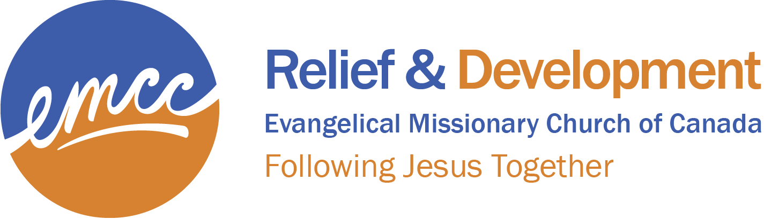

Remittance Form
EMCC Relief & Development 2017-2018

Church:_________________________________________________________
Address:________________________________________________________
City/Town:_________________________________Province:______________
Postal Code:_________________ Phone:__________________________________
Email:______________________________________
Missions contact person:______________________

EMCC – Relief & Development Projects | Project # | $ Donation
- Disaster Relief – for people affected by emergency disasters world-wide | # 102
- Medical Kits – Health Partners’ Physicians’ Travel Packs (PTPs), delivered world-wide by our Volunteer Teams | # 135
- Homes for Haiti Phase 3 – in Benoit following Hurricane Matthew to provide shelter for families. | # 138
- Canadian Foodgrains Bank – a general fund for food security and food aid world-wide | # 180
- Food Aid, Ethiopia – for people in the Kucha Region of Ethiopia suffering severe drought | # 182
- Mobile Training Unit, South Africa & neighbouring countries – training in conservation agriculture | IPF #350
- Nepal, Orphan Care – more that 50 orphans are being cared for by SARA ministries. They need help to provide education for these children. | # 143
- Medical Education, India – support for 10 students to acquire their nursing degrees | # 143
- Sanitation Project, Kolkata, India – bringing safe and environmentally friendly sanitation to villages outside of the city of Kolkata. | # 140
- Medical Health Centre – Gene des Nantes, Haiti – ongoing support for health care in Northern Haiti | #114
- Other:

- Other:

TOTAL DONATION ENCLOSED:

Cheques should be made payable to: EMCC
Please Mail to: Evangelical Missionary Church of Canada
214 Highland Rd. E., Kitchener, ON N2M 3W2

Note that EMCC can now accommodate on-line bill payments directly from your bank account at no extra charge to you. Contact Lotoya Mahorn (lmahorn@emcc.ca) for details on how to set this up.

