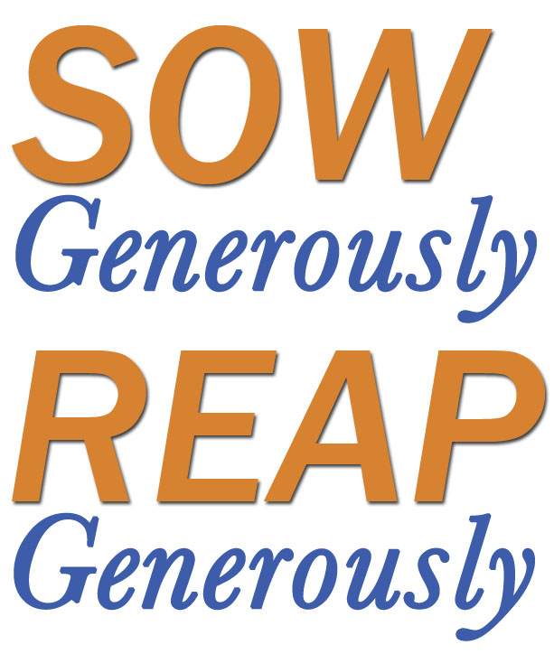
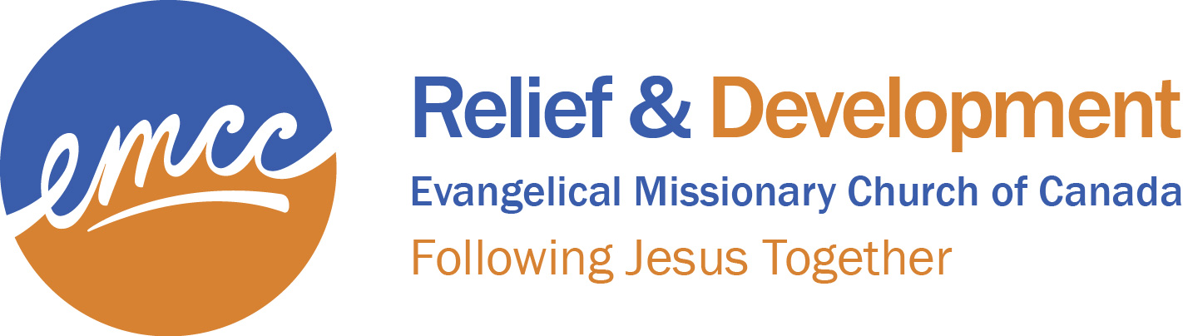

Dear Missions Committee and/or Pastor,

Our EMCC family is privileged to bring a measure of God’s blessing to many places around the globe. Health education and sanitation projects provide a higher quality of life. Agricultural training in “Farming God’s Way” offers tangible hope for families in need of food as well as a new understanding of how following Jesus makes a difference in everyday living. Food for work projects bring life to hungry people and rehabilitation to the land.

We are very pleased that our Relief & Development work is being done through worthy partners who are already on mission with Jesus. Our partnership with them allows them to be the face of God’s blessing among their people.

It’s a joy to see our EMCC family hard at work to be a blessing to the disadvantaged and the poorest of the poor, and to be a hand up to our local partners in several countries. We have seen time and again that when we invest wisely and generously, we reap a bountiful harvest for beneficiaries and for the Gospel.

We would encourage you to make our Relief & Development campaign a special focus during the month of October. We have featured a small sample of our various projects in the printed material provided. Projects that perpetually need funding include our Disaster Relief Fund, PTP medical kits and the EMCC R&D General Fund. Additional resources such as a powerpoint presentation are available at worldpartners.emcc.ca.

Thank-you in advance for your generous support. The involvement of your congregation is vital as we join together to bring relief to disadvantaged and crisis-stricken people.

May God bless you as you minister in your community and reach around the world.

Joel Zantingh
Interim World Partners Director

Enclosures:
- Project List
- Instruction letter to Treasurer
- Remittance form for Treasurers
- Brochures for distribution to your congregation

Let us not become weary in doing good, for at the proper time we will reap a harvest if we do not give up. Therefore, as we have opportunity, let us do good to all people, especially to those who belong to the family of believers. Galatians 6:9-10

