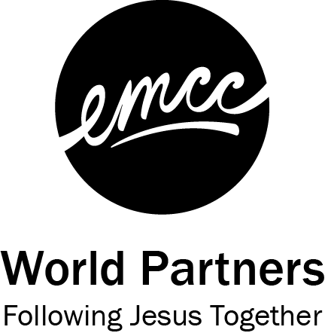

Land Acknowledgment Template
Prepared by Theresa Paplinskie, through participation in the Christian Reformed Church’s Youth Ambassador Reconciliation Program

Acknowledgement Template:

We would like to acknowledge that the land on which we are gathering is the territory of ______________ Treaty. Before the signing of this treaty, the land was occupied by the ______________ people. It is important that we acknowledge the territory to demonstrate respect for the treaty and these people who are the traditional guardians of this land.

Example Land Acknowledgements

Land Acknowledgement for Golden Lake, ON:

We would like to acknowledge that the land on which we are gathering is the territory of the 1850 Robinson-Huron Treaty and 1923 Williams Treaties. Before the signing of these treaties, the land was occupied by the Anishinaabe-Omàmìwininì (Algonquin) people. It is important that we acknowledge the territory to demonstrate respect for the treaties and the Algonquin people who are the traditional guardians of this land.

*Acknowledgement also applies to Petawawa, Deacon, Killaloe, Barry’s Bay and Madawaska.

Land Acknowledgement for Kitchener, ON:

We would like to acknowledge that the land on which we are gathering is the territory of the Haldimand Treaty. Before the signing of this treaty, the land was occupied by the Anishinaabe, the Attiwonderonk, the Haudenosaunee, the Mississauga and the Mississaugas of the Credit First Nation. It is important that we acknowledge the territory to demonstrate respect for the treaty and these peoples who are the traditional guardians of this land.

Land Acknowledgement for Calgary, AB:

We would like to acknowledge that the land on which we are gathering is the territory of Treaty 7. Before the signing of this treaty, the land was occupied by the Niitsítpiis-stahkoii (Blackfoot / Niitsítapi), Ktunaxa, Tsuu T’ina and the Métis. It is important that we acknowledge the territory to demonstrate respect for the treaty and these peoples who are the traditional guardians of this land.

References

Christian Reformed Church. (2018, July 8). The Land We Stand On: A Territory Acknowledgement Guide. Retrieved on August 26, 2020, from https://network.crcna.org/biblical-justice/land-we-stand-territory-acknowledgement-guide

Native Land. (n.d.). Territory Acknowledgement. Referenced on August 26, 2020, at https://native-land.ca/territory-acknowledgement/

